**Ball Reloading and Reservoir Mechanism**

Done by Romain Nith on the 27/03/17

Problem: To reduce the distance traveled by the robot, we need to design a reservoir to store the balls retrieved at the ball dispenser. The reservoir will store and reload the crossbow at the same time.

Version 1:

By traveling, the robot is prone to errors and is not expected to arrive at the ball dispenser perfectly. To prevent the robot from not being able to retrieve any ball, the reservoir would look like a funnel feeding the ball into a rail that leads directly to the firing chamber.

To pull up the entire system, a pulley mechanism with a string is being used. The string will be winded by the same motor used to pull on the crossbow trigger. It has been design to not pull on the trigger when a ball in being dropped to the chamber: rotating clockwise will lift the reservoir and counterclockwise will pull on the trigger while lifting slightly but not enough to roll a ball into the chamber.

Iteration 1:

The reservoir’s floor is being made with Lego blocks

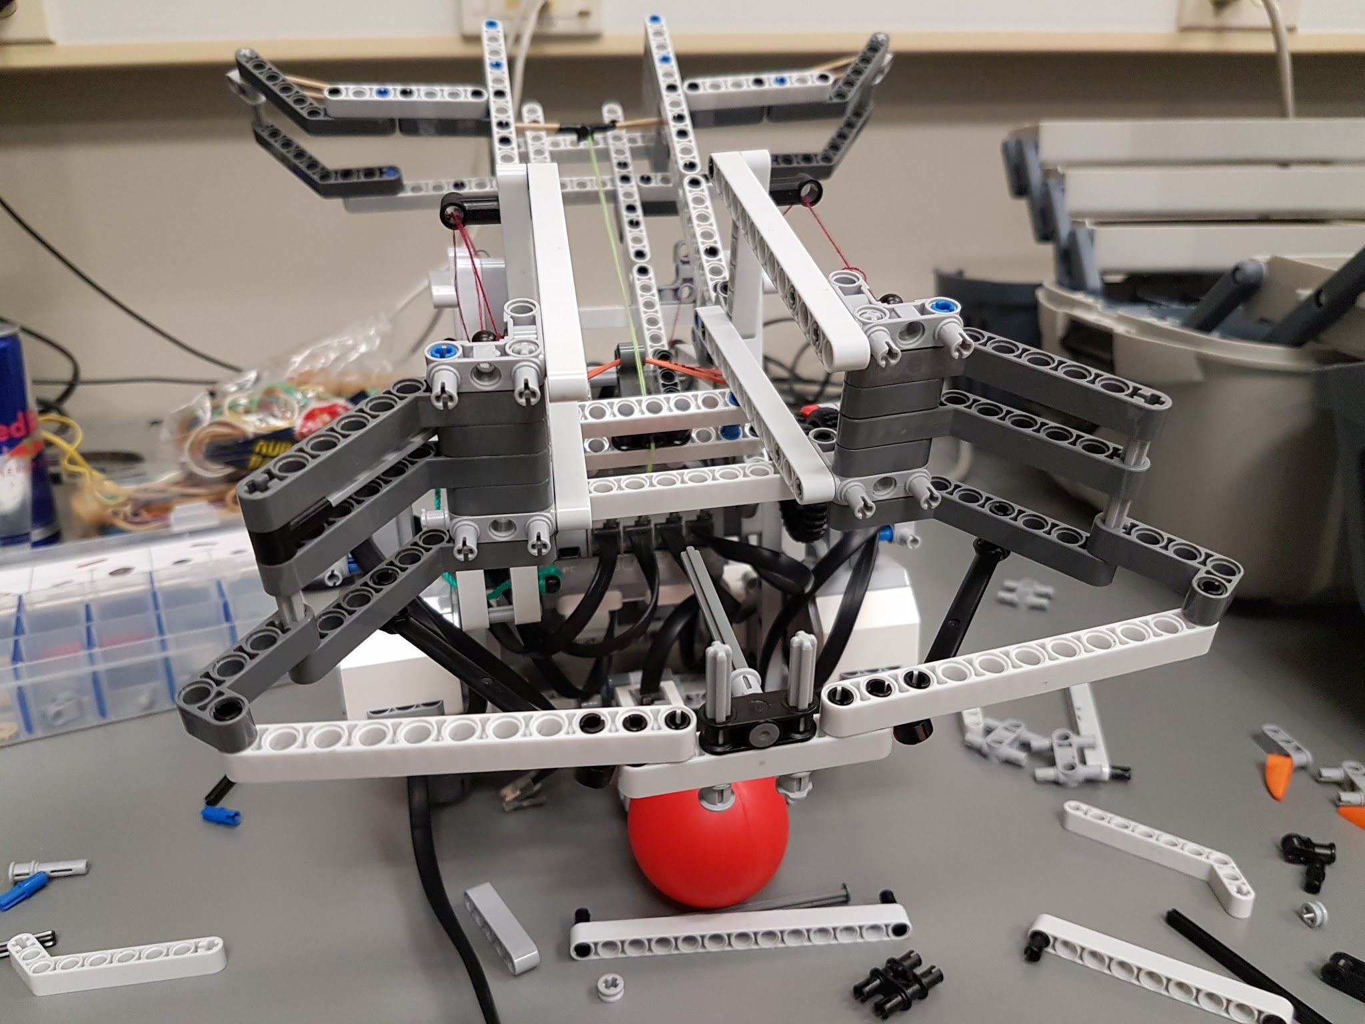

Issue: the reservoir is too large and balls would get stuck

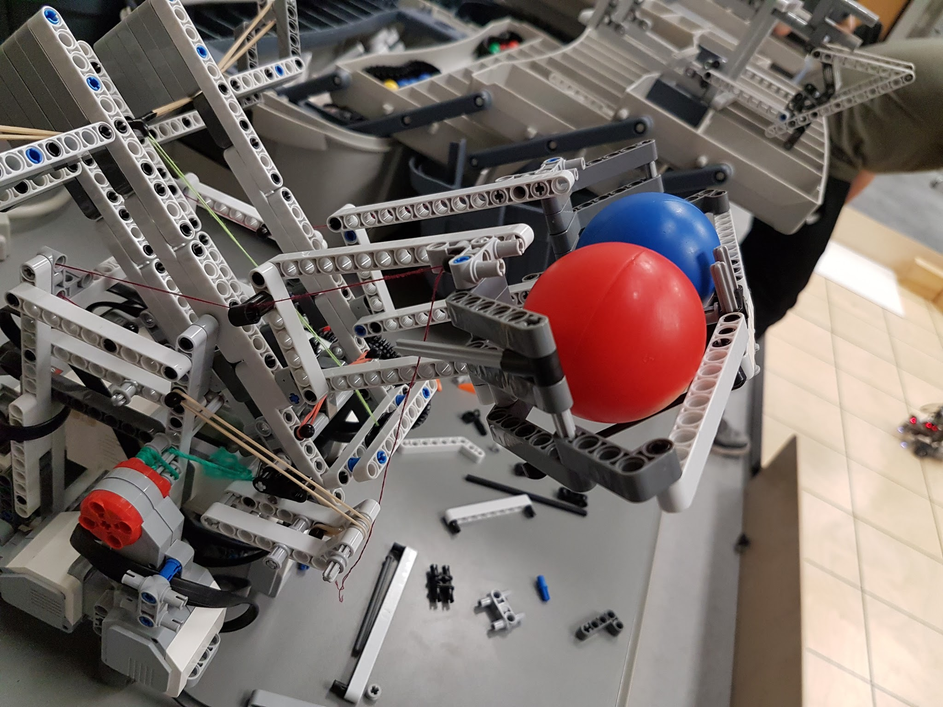

Iteration 2:

Change the reservoir to lift the height of the floor so the balls would fall into the rails more easily. Floor being made out of paper.

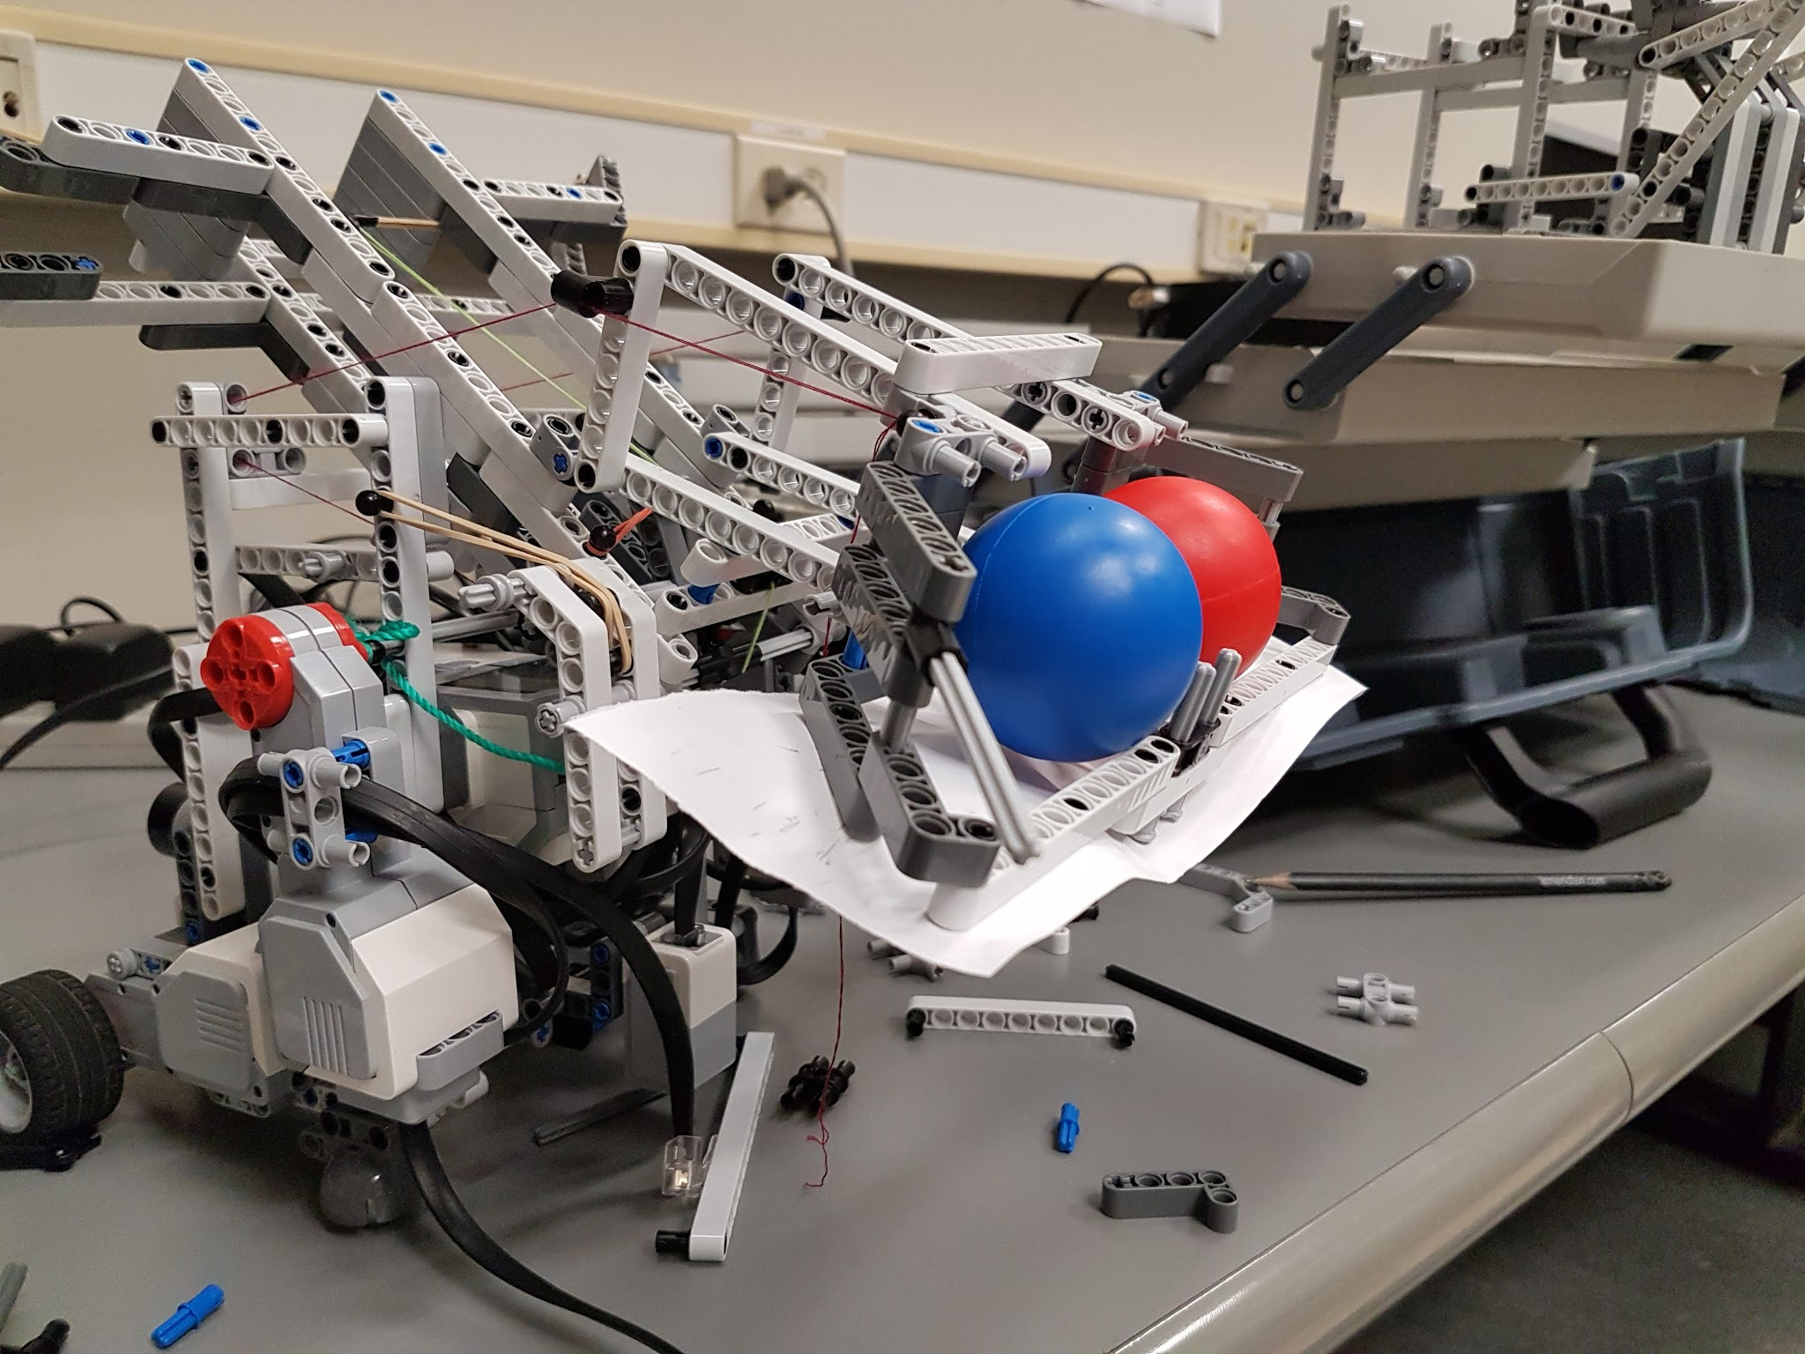

Issue: reservoir still too large and balls would get stuck

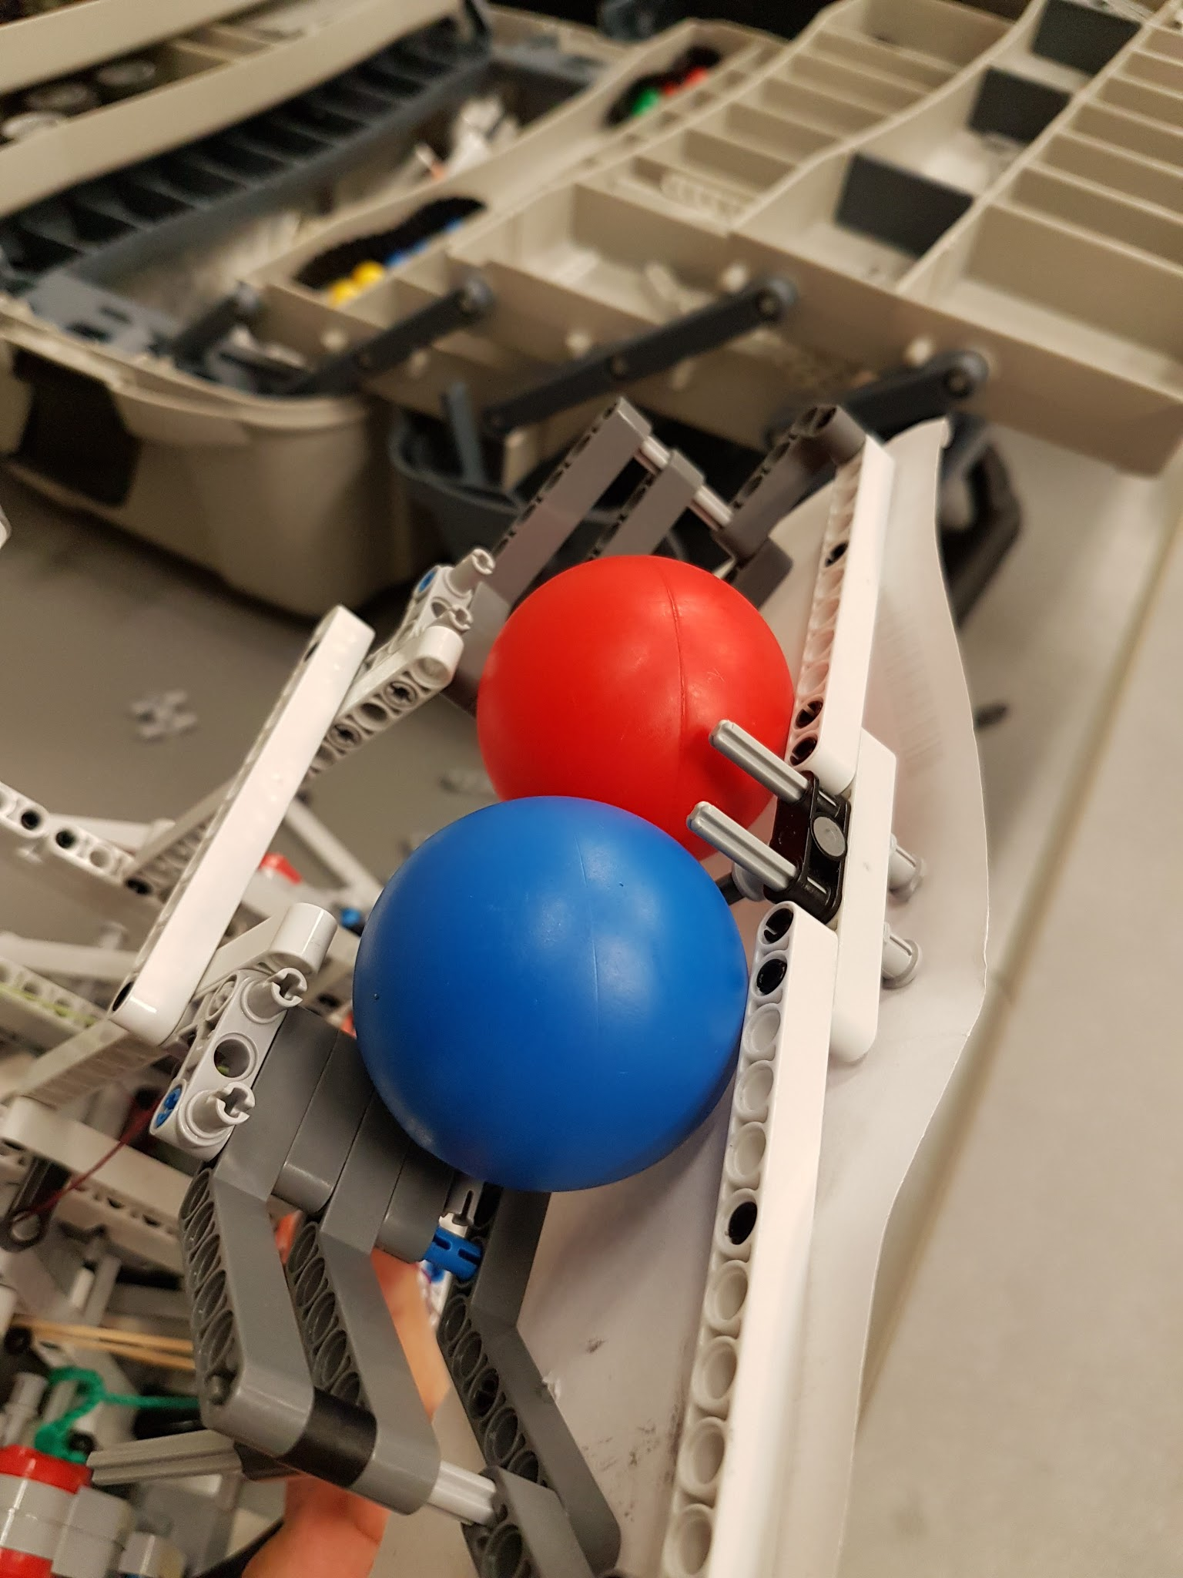

Iteration 3:

Reduce the extension of the funnel’s exterior arms

Issue: Issue: reservoir still too large and balls would get stuck

Version 2:

Assume the robot arrives at the dispenser with only plus or minus 2cm of error. Instead of a funnel, the robot would only have a large rail so the balls just stay aligned and are directly in the main rail ready to be dropped into the firing chamber.

Iteration 1:

Using the same rail of the previous version.

Issue: the opening isn’t wide enough and the robot had to be precisely under the dispenser to retrieve the ball

Iteration 2:

Shortening the upper rail for a wider opening.

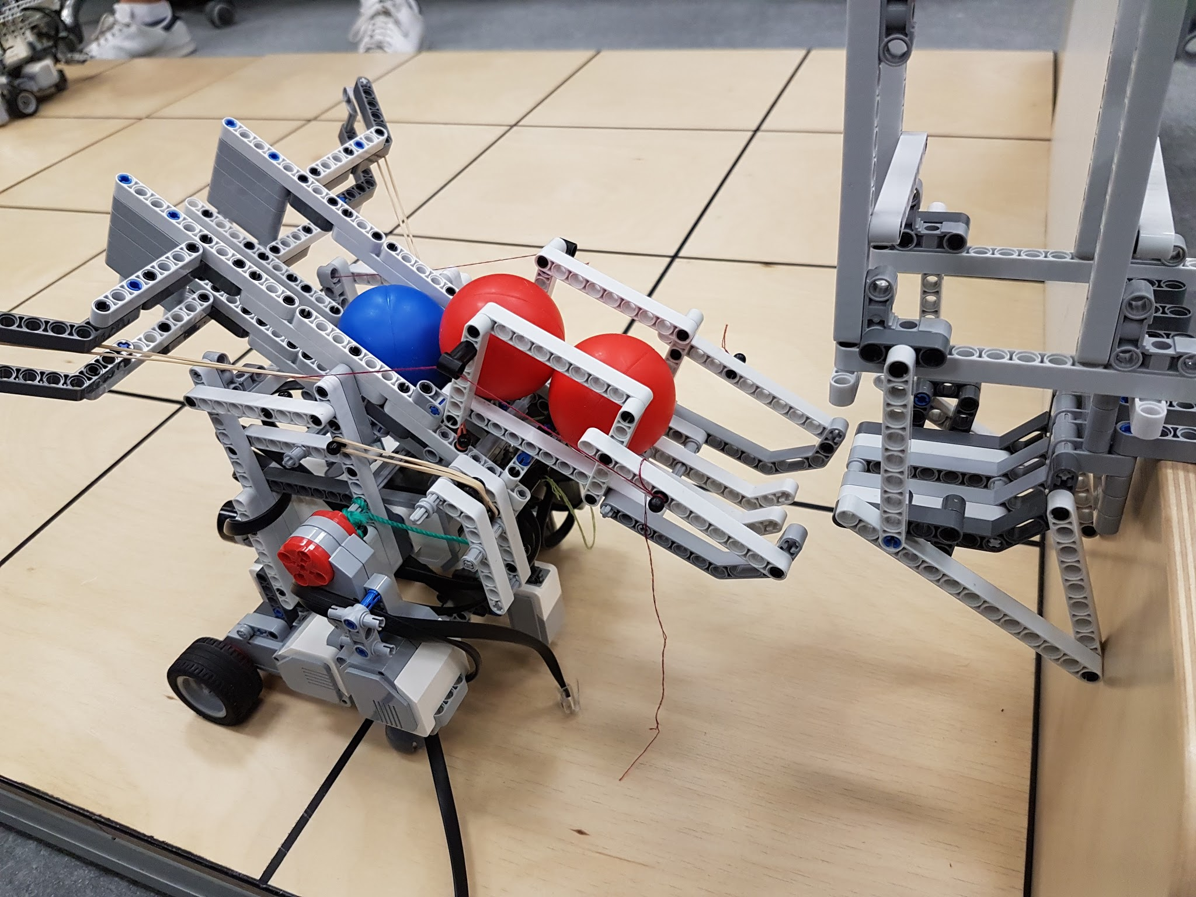

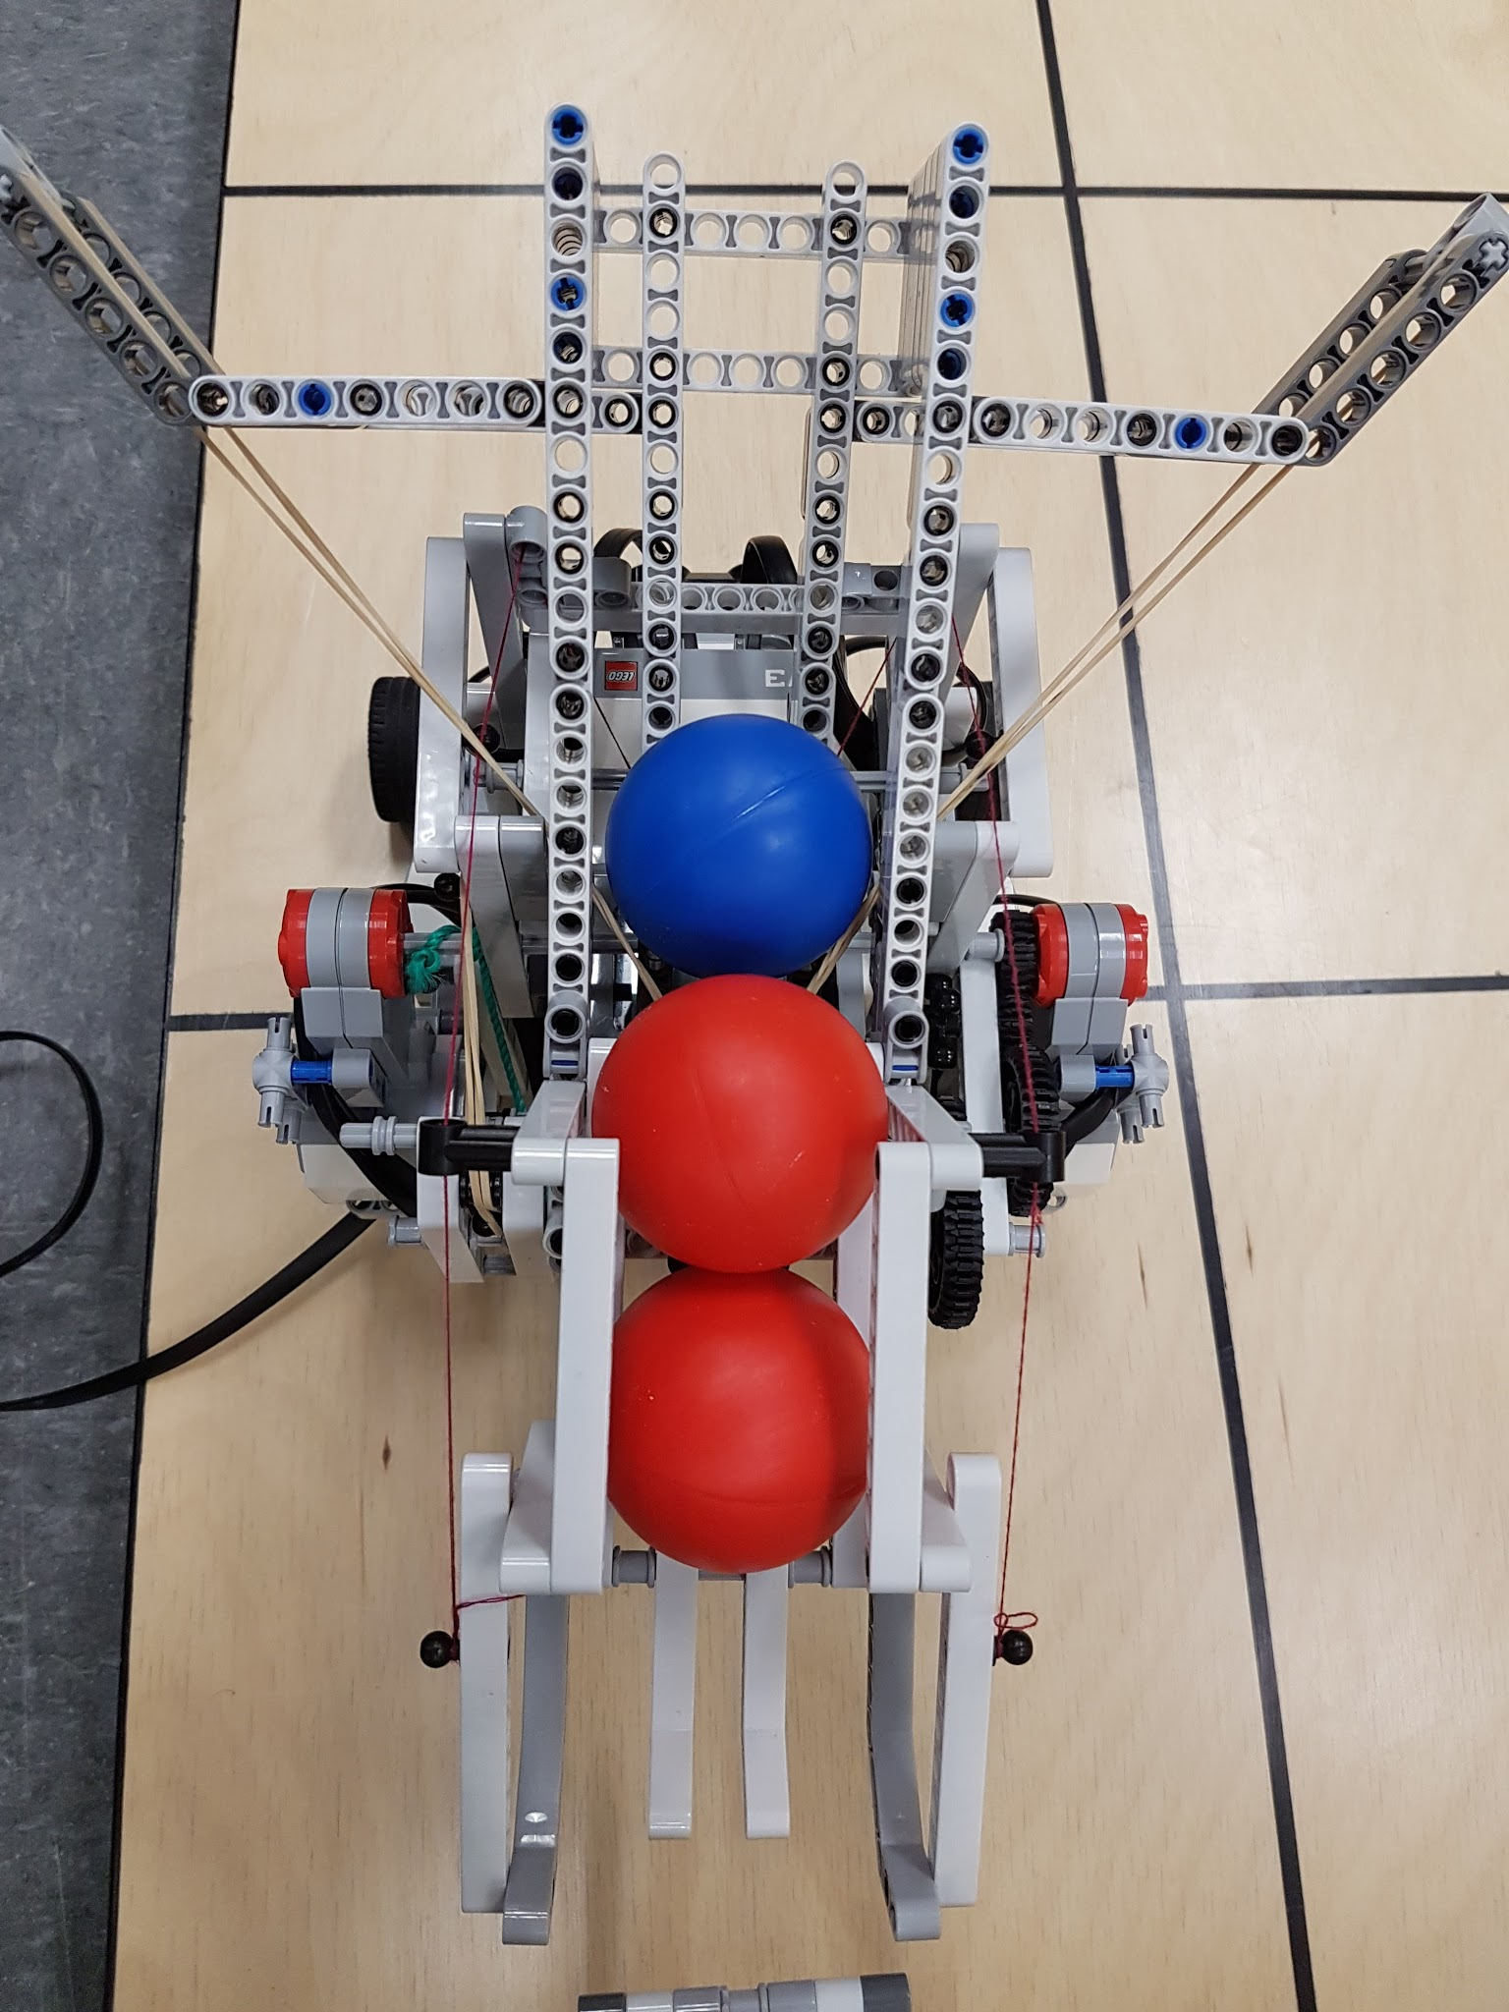

Result: works with [2.8; 3.3] cm of errors according to Dispenser Test document